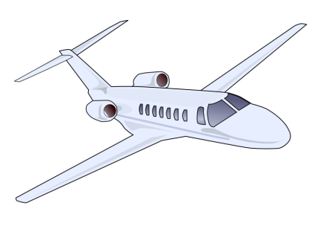
Community Service Standards and Procedures
MINIMUM AGE OF 16 YEARS (NO EXCEPTIONS)
Madison Municipal Airport welcomes volunteers who are required by a court or other agency to do community service. Madison Municipal Airport reserves the right to deny ANY individual in need of court ordered community service hours the ability to volunteer with the airport based on the nature, type and/or specifics of their offense. Madison Municipal Airport will not be a party before the specific Court which orders the service, there is no jurisdiction over the organization and the Courts cannot order Madison Municipal Airport to allow an individual to volunteer with our organization.
Individuals will be judged solely by their offense(s) and not by any other means, including, but not limited to: age, race, religion, sexual orientation, or disability.
How to Apply:
- Must be at least 16 yrs old (no exceptions)
- Submit completed application form (can be found at madisonmunicipalairport.com) via one of the following ways:
  - Email to airport@madison-in.gov and airportasst@madison-in.gov
  - Website (madisonmunicipalairport.com)
  - In person
Scheduling work days:
- Call ahead to schedule. Let us know dates, times, and how many hours you would like to work. (Madison Airport Staff need to know prior to you just showing up, but please don’t schedule if there is a possibility that you will have to cancel and reschedule a work day.)
- There is a strict 3 strike policy regarding No-Shows and Cancellations. After 3 No-Shows or cancellations any further scheduled work days will be considered cancelled and services no longer required. (No Exceptions)
Rules and guidelines:
- WORK ETHIC:
Be ready to work! We expect that all of our volunteers show up to work on time, respect staff members, and do the work that is needed to be done. If you are found to be unproductive, you will not earn any volunteer hours for that day. If you have completed a task and need something to do you are required to see airport staff to be assigned your next task.
  - No Phone – The use of a personal phone the work period is prohibited.
  - No Friends – Do not bring friends with you, they will be asked to leave.
  - No Smoking – Smoking will not be permitted during the work period
- DRESS CODE:
  - As some work will be outdoors dress with the weather in mind (is it going to be hot, cold, etc.)
  - Clothing must be presentable as Madison Municipal Airport prides itself on its professionalism, and welcoming atmosphere.
    - No tank tops, sleeveless, low cut or short cut shirts.
    - No short-shorts
- CODE OF CONDUCT:
  - We do not permit the use of foul language, drugs or alcohol, or any kind of physical or verbal abuse. If you are caught doing any of the above you will be asked to leave and will not have the opportunity to finish your hours with us.
  - If at any point airport staff suspect you are under the influence of drugs or alcohol you will be asked to not return and police will be called.
Potential Task Assignments:
Includes but is not limited to the following:
- Weeding
- Painting
- Cleaning / sweeping Hangar
- Cleaning windows
- Vacuuming
- Trash collection
- Mopping
- Cleaning bathrooms
- Cleaning courtesy car
- Cleaning plow/airport tug and other airport equipment
- Cleaning tie down areas and holes
- Other more advanced and skilled projects

***Please note: The Madison Municipal Airport reserves the right to terminate the agreement for community service if the participant is in any way unproductive, disruptive, or in any other way negatively impacts the accomplishment of the daily goals or organizational image.

